## Merchant Name: Anrok Implementation POC: Royce *(IM to fill)* CX POC: *[IMP to Add]*

### 

### 

| Notes Sections   *(AE to fill if they have, Implementation to be completion DRI on handoff)*   * Info on how merchant bills   We are handling their enterprise segment. Flat subscription fee and tiered unit pricing for Toal $ amount of taxable products. Currently sending 20-30 invoices a month with the enterprise customers. Countsy is handling invoicing today but they are moving this in house to HanYue.  1) What is the merchant temperament?  Already a partner of ours and very excited about the relationship. Selina (VP of Finance) is our champion - very nice, smart and going on maternity leave in September. She’ll oversee the Tabs implementation HanYue (Controller) will be the Tabs power user. She joined in April. Very nice and a Tabs champion.  Emily (Head of Accounting) is a seasoned finance vet. She jpoinged the team at the end of May and is still onboarding. Will be intently interested in Month end close and reporting.  3) What are the Tabs features that the key POC cares about?  Contract Management - Currently translating all contract data manually from SFDC to NS. Pulling key terms from contracts and auto generating invoice schedules/invoices is massive ROI.  Invoices/Collections - Country handles this and they are moving the process in house. No visibility into DSO or overdue invoices before EOM.  Rev Reporting - Some Usage billing that is difficult to keep accurate schedules in Spreadsheets. Autogenerate schedules will be a big value add  Cash App - Autoapplyment of payments to move Countsy out of the process  NS/SFDC Integrations - Nothing talks to each other today. Siloed systems and manual translation of data. |
| --- |

### Billing model *(Entire Section: Implementation to fill section)*

### *Hi Ops team! The 3 contracts for Initial Calibration needed are below:*

### *Retool Core Annual*

### *Enterpret*

### *Harness Growth*

* Are there unique things about the customer creation process for this merchant?
* Information on how merchant bills
* How contract is broken up
* One off things to know about the merchant
  + Anrok is a current Partner of Tabs and we offer an integration with their platform out of the box

### Contract Processing Steps *(Entire Section: Implementation/Success to fill Post-Go Live)*

1. Steps to process

Customers

* You should not have to make any customers. Please flag if the customer doesn’t exist

BTs to create:

* Process each line item in the table as a product
* Include discounts in line - example below can be in line in the BT
  + If there is a free period, billing and revenue should **still** start on the stated “term start date”



* **Do not process contracts that are invoiced monthly.** It will say “total due monthly” in the pricing summary. If you come across one of these, mark it as processed without BT

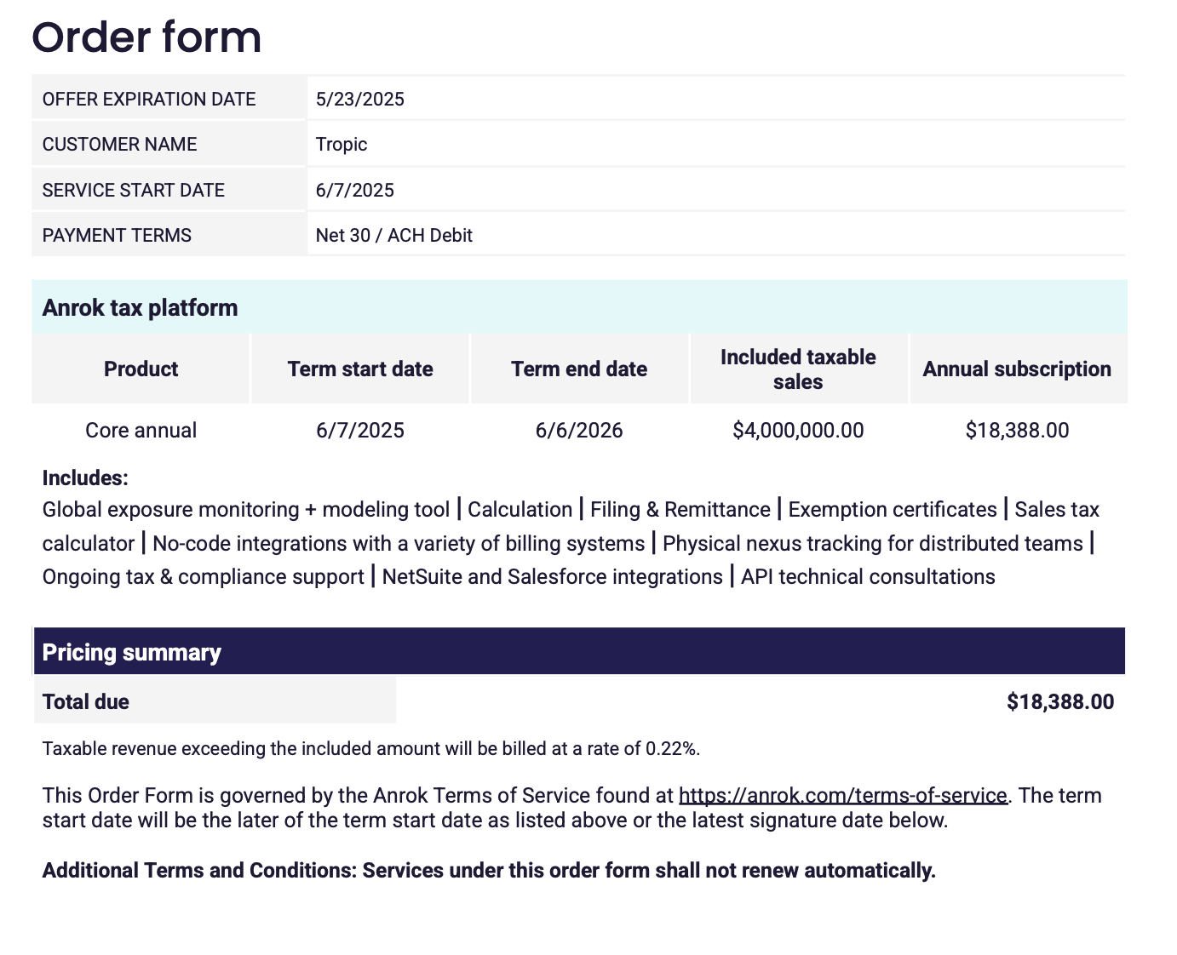

**Item Name:** Use the name listed in the product column (e.g., "Core annual", "Anrok for Startups", "Growth annual")

* Example above would be “Core annual”
* Ignore the included taxable sales column and the fineprint
  + We will **not** be creating usage BT - this is referring to events to track. We will not be creating BTs that have an event to track
* If a free ramp period is included, ignore and do not include as a BT
  + Service Start Date/Rev Rec should still be from the stated term start date until the term end date and billing start date should be = service start date
  + Example below would have 2 BT

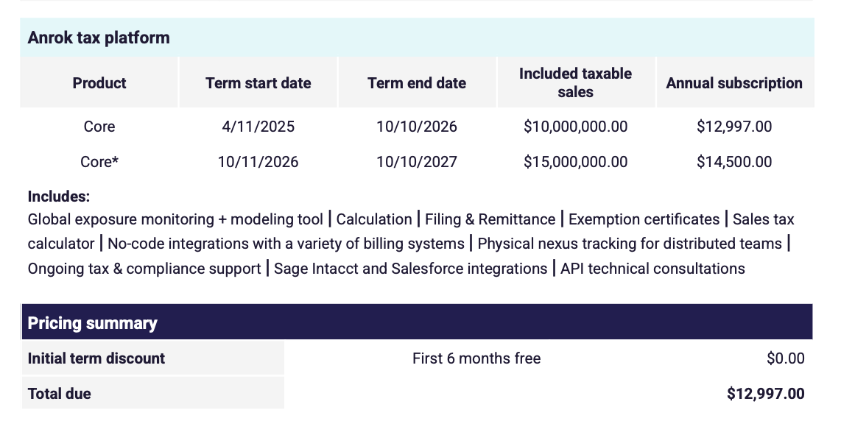

1. Core; service start date: 4/11/25 for 18 months; billing start date 4/11/2025; period 1; frequency 18 months; price $12,997
2. Core; service start date: 10/11/26 ~~for 12 months~~; months of service until 10/10/2050; billing start date 10/11/2026; period 1; frequency 1 year; price: $14,500

**Item Description:** not necessary

**Quantity:** Default to 1 unless explicitly stated.

**Total Price:** Use the price listed for the individual billing period. Should be an “annual subscription”. Please flag if it is not

Example below - use the “total due” amount. BT would be called “Core Annual”

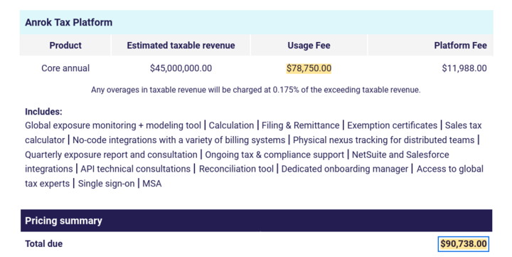

**Service Start Date:** Use the "Term start" or "Period start" date from the pricing table

**Billing Start Date:** Match Service Start Date unless specific invoicing instructions are present.

**Billing Type:** Flat

**Months of Service:**

* For the last BT - use the number of months to get to 2050
  + In the example above, you would extend the 2nd BT until the the end of the subscription term in 2050
* Calculate based on the difference between Period/term start and Period/term end.
* Round to whole months (e.g., 3 months for 7/1/2025–9/30/2025; 12 months for 10/1/2025–9/30/2026).

**Frequency:**

* Use frequency in the “payment terms” section e.g. set to Year if "Annual subscription"
  + Default to year if nothing is explicitly stated
* Calculate number of periods based on frequency

**Number of Periods:** extend the last BT so that billing ends 2050

**Net Terms:** Use terms listed at the top of the contract or in the fees section; default to 30 if unstated.

**Billing Timing:**

* First of period

**Integration Items:**

* Anrok Platform Annual for every BT

**Examples:**

1. Anything to ignore in contracts?
2. Specifics processing things the merchant has requested that may differ by contract (e.g. always back-date invoice date to final day of the month)
3. Default Service Term
   1. If None Listed, Ops Default is 1 Year
4. Default Net Payment Terms
   1. If None, Ops Default is 0
5. Default Billing Frequency
   1. If None Listed, Ops Default is Monthly
6. How do we handle taxes as a line item?
   1. If None Listed, Ops Default is every tax line item becomes a BT

### Events Processing (if necessary) *(Entire Section: Implementation/Success to fill Post-Go Live)*

* Any important information on events billing

Integration Items Processing (if necessary)  
*(Entire Section: Implementation/Success to fill Post-Go Live)*

* What are the instructions for assigning integration items?
* Example: All Statsig integrations items should be labeled as “Sales”
* Example: All “Pinata” integration items should be labeled as “Software Subscription Bundle” unless otherwise noted by Merchant

Post Processing Communications (if necessary)  
*(Entire Section: Implementation/Success to fill Post-Go Live)*

* Does the Ops Team need to notify anyone on the team re: completion of processing batches in Implementation or Active phase?
* Who needs to be notified and when?
  + Example:
    - Who: Customer Success [Azmat Aziz] needs to be notified
    - Where: Messari internal merchant channel
    - When: contracts are processed [Merchant Phase: Active]

### Customer Information *(Entire Section: Implementation/Success to fill Post-Go Live)*

* Any important information on specifics customers of this merchant
  + Special memo’s certain invoices require
  + Invoice changes due to merchant/customer relationship

### Feature Requests *(AE to fill for all requests prior to Imp handoff, Imp to fill prior to go-live/Success to fill to fill Post-Go Live)*

* Handling their SMB Business
  + It’s their other segment outside of enterprise. Strictly real time usage billing in their app
  + Tabs could handle 100% of their billing. Would be API work to push invoices generated in Tabs to their app
  + Low. We are aligned on only supporting their enterprise business in the SOW and sales process
  + Tiered for billing - Demo env

### Merchant Calls *(AE to fill for all videos prior to Imp involvement, Imp to fill prior to go-live/Success to fill to fill Post-Go Live)*

* Disco:
  + https://us-56595.app.gong.io/call?id=3466057865361804783
* Demo
  + https://us-56595.app.gong.io/call?id=4117055528466818933
* Demo - Enterprise Workflow
  + <https://us-56595.app.gong.io/call?id=2100036466179227380>
* POC Kickoff
  + <https://us-56595.app.gong.io/call?id=5134506017868582599>
* POC Wrap Up
  + <https://us-56595.app.gong.io/call?id=2899793354001067315>
* Path to Partnership
  + <https://us-56595.app.gong.io/call?id=6251739346428489001>
* ROI Discussion
  + <https://us-56595.app.gong.io/call?id=8713876302251405766>
* Commercial Alignment
  + <https://us-56595.app.gong.io/call?id=8810264256902447165>
* Accounting with Emily
  + <https://us-56595.app.gong.io/call?id=1394215840612473461>
* Accounting with Emily Part 2
  + https://us-56595.app.gong.io/call?id=4876324589174760727